**MVC Project Documentation**

**Overview**

This document provides a detailed overview and guide for your MVC project. The project is structured using the Model-View-Controller (MVC) design pattern and includes middleware, routing, and controller logic to manage application behavior.

**Project Structure**

The project is organized into the following directories:

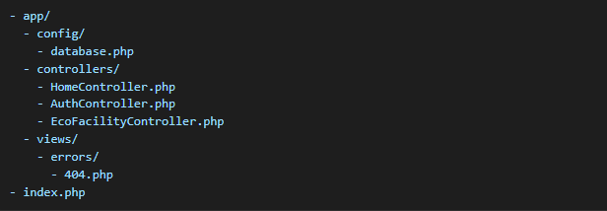**Directories Explanation**

* app/config/: Contains configuration files for database and other application settings.
* app/controllers/: Contains the controllers that handle business logic for different routes.
* app/views/: Contains the view files that render HTML responses to the client.
* index.php: Entry point of the application, responsible for bootstrapping and dispatching routes.

**Routing System**

The routing system defines how HTTP requests are mapped to specific actions in the controllers.

**Route Definition**

Routes are defined using the route function in index.php:

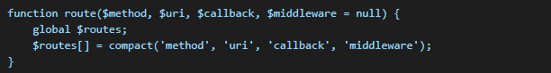

**Route Dispatching**

The dispatch function processes incoming requests and matches them to the defined routes. If no route matches, it returns a 404 response.

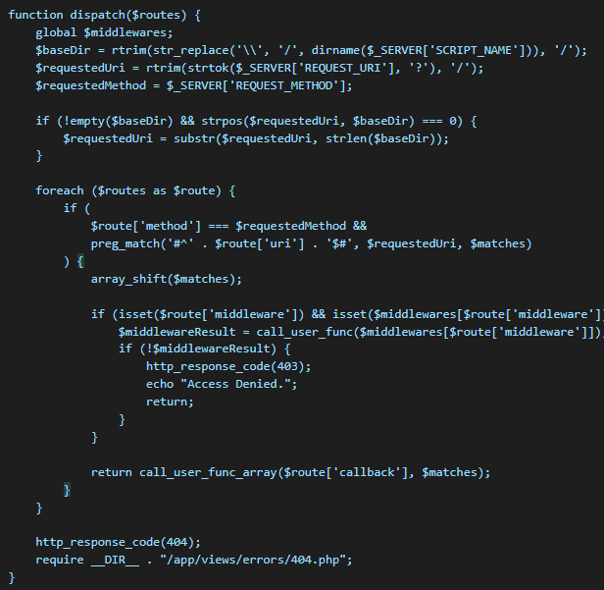

**Middleware**

Middleware is used to execute logic before accessing specific routes. Middleware is defined using the middleware function:

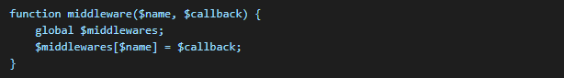

**Defined Middleware**

1. **Auth Middleware** Ensures that the user is logged in.

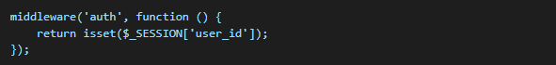

1. **Manager Middleware** Ensures that the user has the Manager role.\

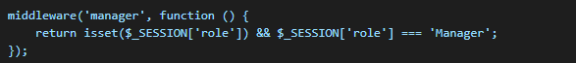

**Controllers**

Controllers handle the business logic for the application and return the appropriate response to the client.

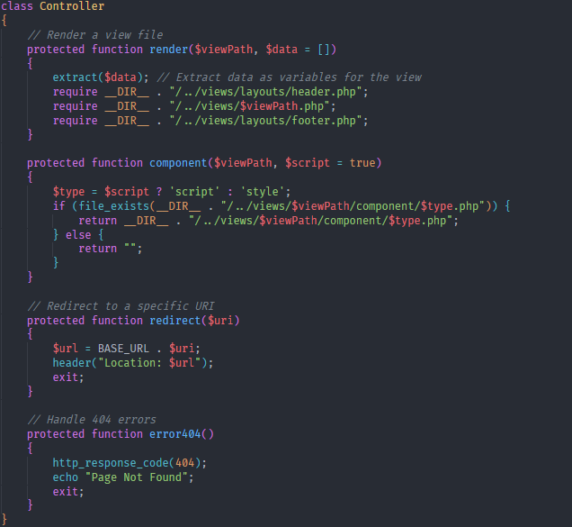

Please Check EcoFacilityController to Check Controller Implementation

**How to Add a New Route**

1. Define a route in index.php:



1. Create the corresponding controller method in YourController.

**Test Results to Fetching 100 Data from 10.000 Data**

shows at speeds below 500ms, using pagination and limits